Assignment 4 – Networks.

Part B -

Port Scanning :
To detect the open port port, we use the nmap shell command :
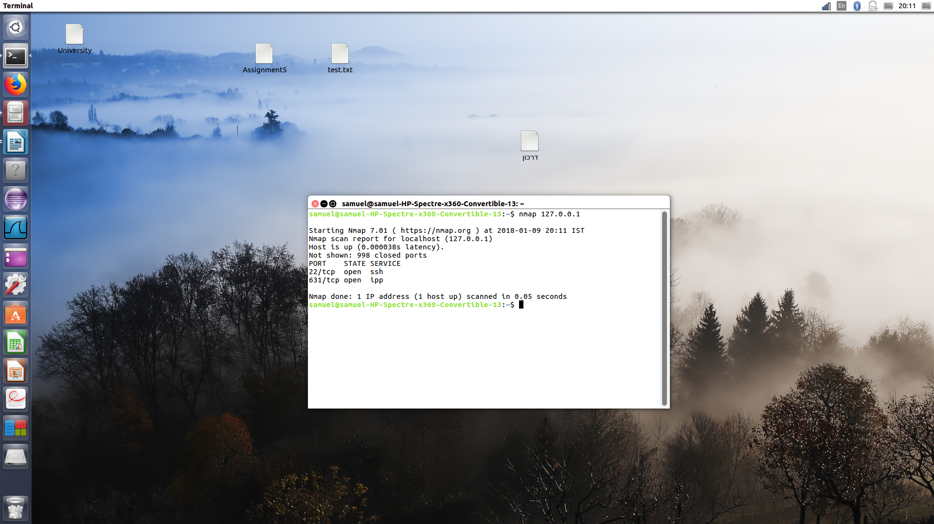
screen-shot of the terminal when using the nmap program.
We can read that two ports are open : the 22 (ssh) and the 631 (ipp)
Here the Wireshak screen-shot.
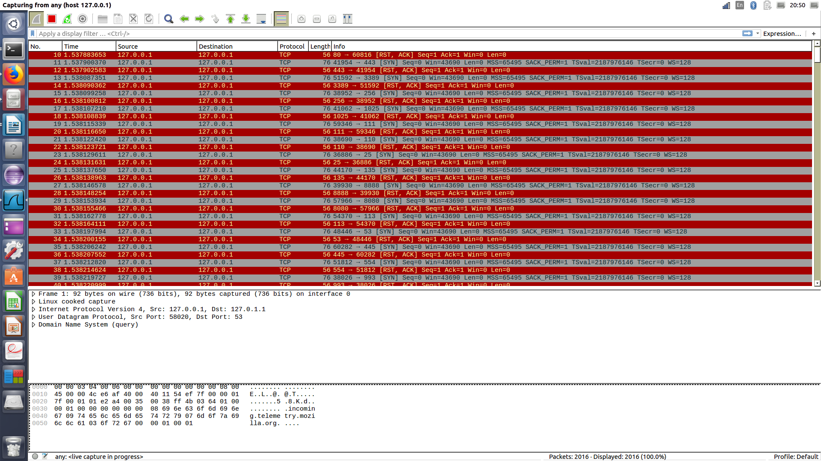
Password Guessing :
To crack the password, we use the hydra shell command :
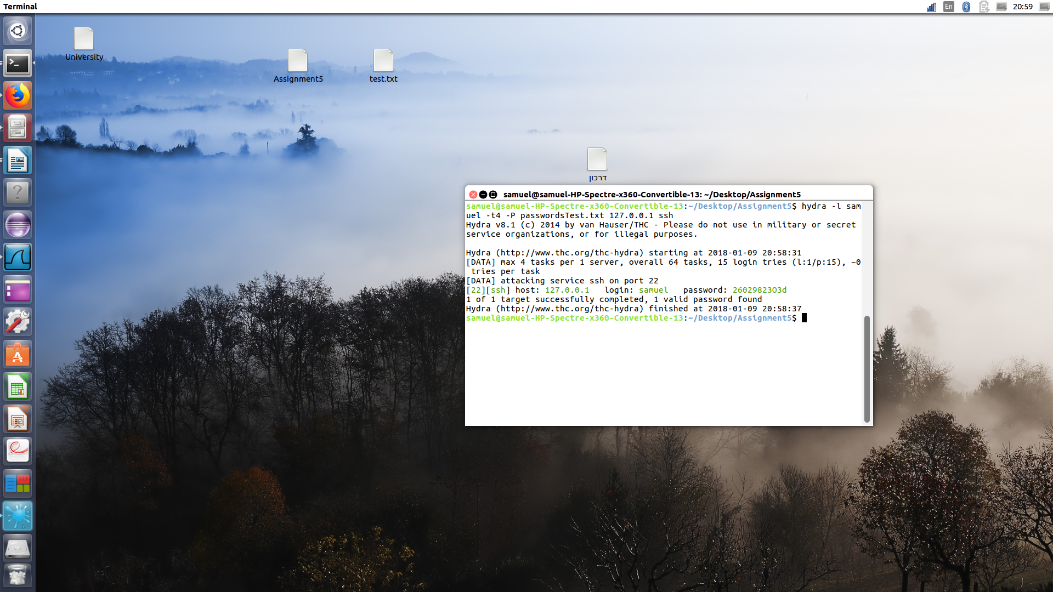
screen-shot of the terminal when using the hydra program.

As we can read, my (localhost) password have been detected (2602….)
Here the Wireshak screen-shot.

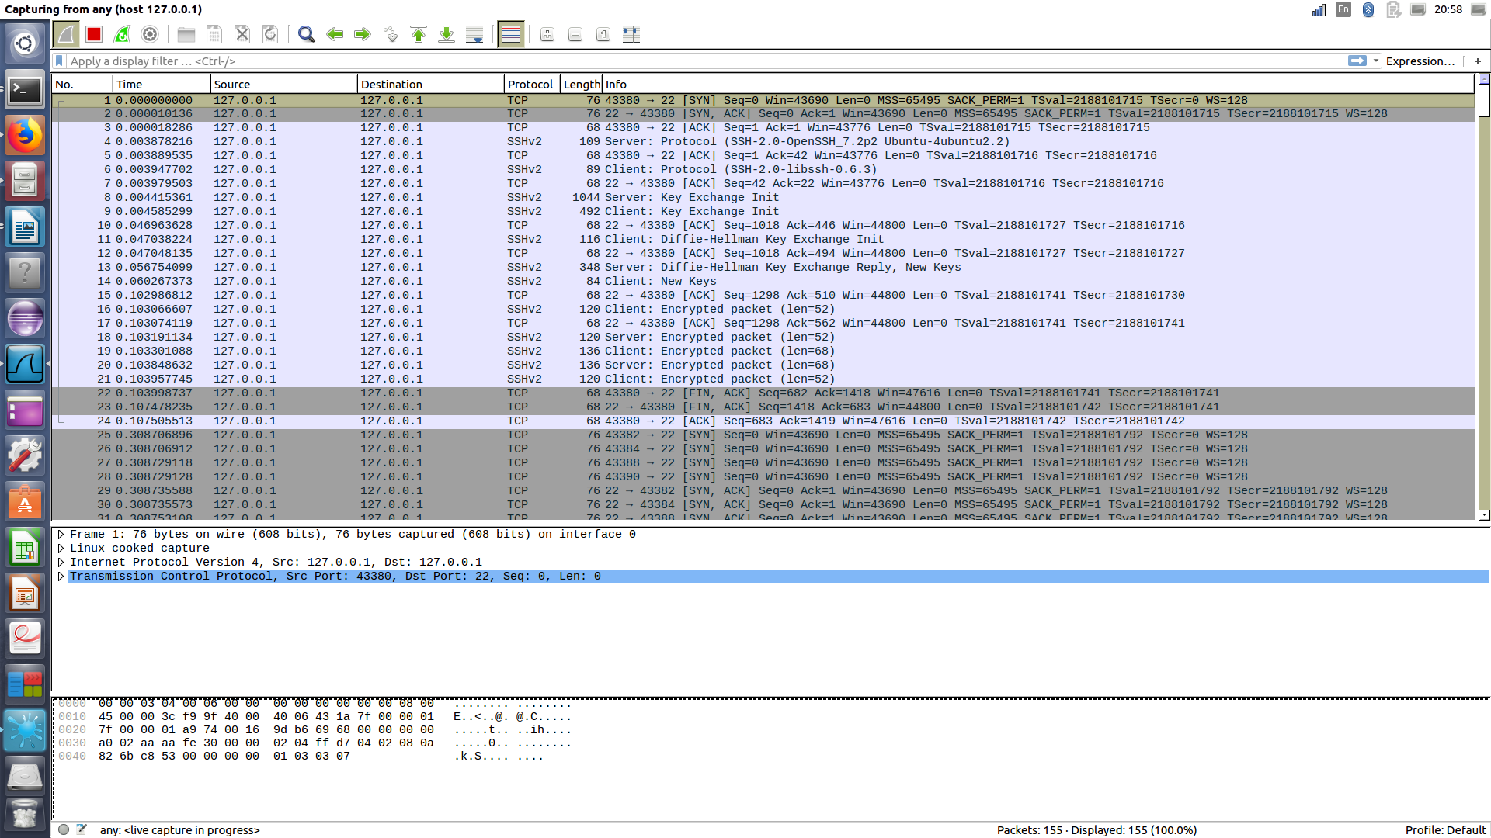

Stealthy FTP client :

To steal the file, we use the filezilla shell command:
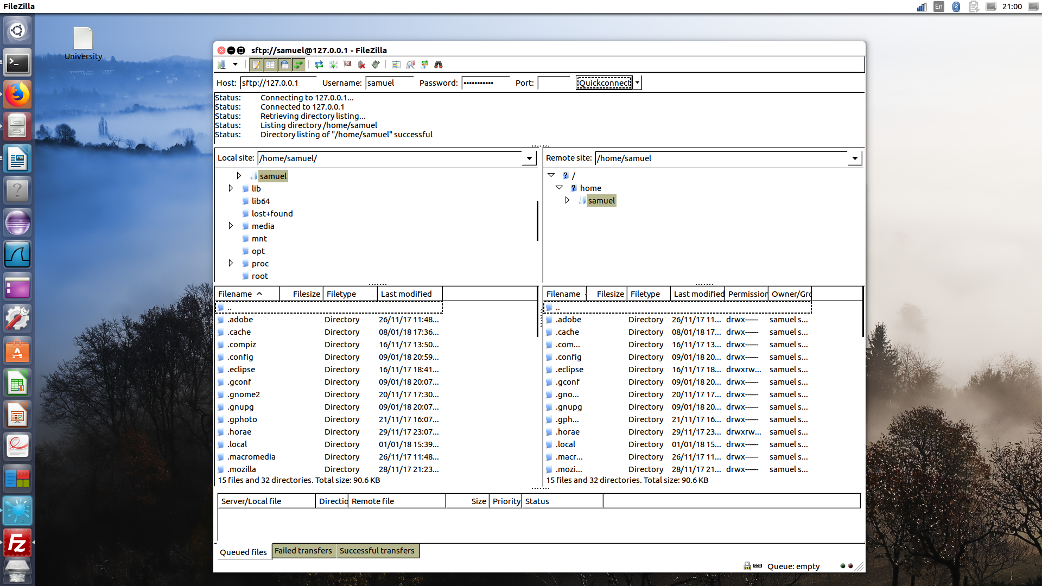
screen-shot of the use of the filezilla program.

As we can see, after we input the host, the username, the password and the port, we got all the files of the target computer.
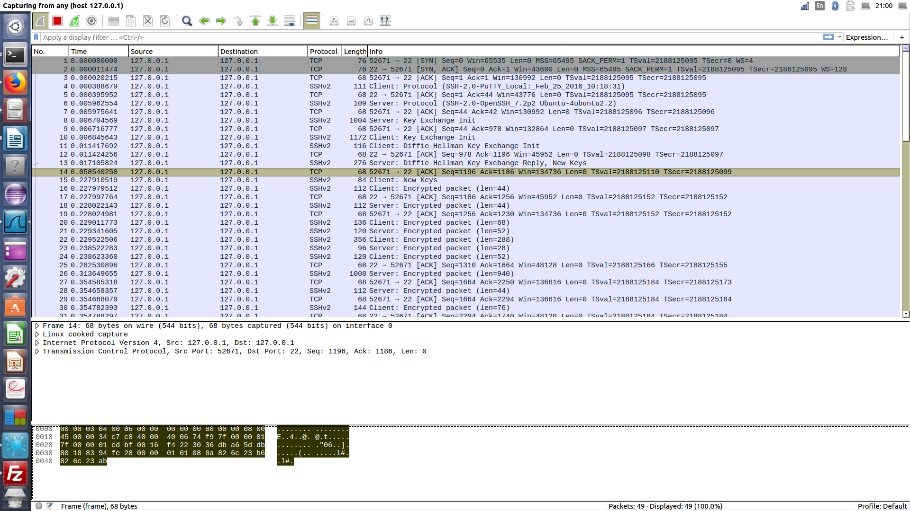
Here the wireshark screen-shot.

